DIGITAL MARKETING ANALYTICS
A DATA-DRIVEN STUDY OF DIGITAL CAMPAIGN PERFORMANCE

PROJECT REPORT
Submitted in partial fulfilment of the requirements for the award of the degree of
MASTER OF BUSINESS ADMINISTRATION
Academic Session: 2026–2027

SUBMITTED BY
[ABHISHEK KUMAR GUPTA]
Roll Number: [25050020001]

UNDER THE GUIDANCE OF
[Mr Ferhan Ahmed]

UNITED UNIVERSITY
Prayagraj, Uttar Pradesh
PREDICTIVE ANALYTICS

ACKNOWLEDGEMENT
I express my sincere gratitude to my project guide and faculty members for their guidance, encouragement and academic support during the preparation of this report. Their suggestions helped me understand the role of data analysis in evaluating digital marketing activities.
I also thank United University for providing the academic environment and learning resources required to complete this project. I am grateful to my classmates, friends and family members for their support.
This project strengthened my understanding of campaign metrics, channel performance, data preparation and evidence-based marketing decisions.

ABSTRACT
Digital marketing has become an important part of organizational communication, customer acquisition and revenue generation. Businesses use channels such as social media, search advertising, email, display advertising and content marketing to reach audiences. However, campaign activity alone does not establish effectiveness. Marketers must evaluate measurable indicators such as impressions, clicks, click-through rate (CTR), cost per click (CPC), conversions, conversion rate, revenue and return on ad spend (ROAS).
This project examines how digital marketing analytics can support the evaluation of campaign performance. A synthetic dataset of 120 campaign records was created for academic demonstration. The dataset includes channel, campaign objective, budget, impressions, clicks, conversions and revenue, along with calculated performance indicators. Descriptive analysis and visual comparisons are used to identify differences among channels and to demonstrate how campaign data can inform marketing decisions.
The illustrative dataset contains total campaign expenditure of ₹4,157,283, 61,879,156 impressions, 2,023,176 clicks, 107,582 conversions and recorded revenue of ₹207,901,817. The aggregate CTR is 3.27%, average cost per click is ₹2.05, conversion rate is 5.32% and aggregate ROAS is 50.01. These values are calculated from the synthetic records and must not be interpreted as industry benchmarks or actual company results.
The report concludes that analytics can improve campaign monitoring, budget allocation and optimization, provided that data quality, attribution, privacy and measurement limitations are considered.
Keywords: Digital Marketing, Marketing Analytics, Campaign Performance, CTR, CPC, Conversion Rate, ROAS, Data-Driven Decision-Making.

TABLE OF CONTENTS

Section | Particulars
1 | Introduction
2 | Problem Statement
3 | Review of Concepts
4 | Research Methodology
5 | Dataset Description and Data Preparation
6 | Analytical Framework and Tools
7 | Analysis, Visualizations and Findings
8 | Recommendations and Suggestions
9 | Limitations of the Study
10 | Conclusion
11 | Learning Outcomes
12 | Bibliography
Appendix A | Sample Dataset

Note: Page numbers may change when the report is edited or opened in a different version of Microsoft Word. Update the table of contents after final formatting.

INTRODUCTION
Digital marketing refers to the promotion of products, services and brands through digital channels and platforms. It includes search engine marketing, social media marketing, email marketing, display advertising, content marketing and other online communication methods. These channels allow organizations to reach defined audience groups, communicate value propositions and measure user responses.
The growing availability of digital data has changed the way marketing performance is assessed. Instead of relying only on broad estimates such as reach or brand visibility, organizations can monitor detailed campaign indicators. Impressions show how often content is displayed, clicks indicate interaction, conversions represent desired actions, and revenue connects campaign activity with commercial outcomes.
Digital marketing analytics is the systematic collection, measurement and interpretation of data generated by marketing activities. It helps marketers understand which channels are attracting attention, which campaigns are generating qualified actions and where budgets may be used more efficiently.
This project uses an illustrative campaign dataset to demonstrate how performance metrics can be calculated, compared and interpreted. The focus is on channel-level comparison and the use of evidence to support practical marketing decisions.

Background of the Study
Organizations increasingly operate across multiple digital touchpoints. A customer may first discover a brand through social media, search for product information, read online content and later respond to an email offer. Because customer journeys can involve several channels, performance measurement requires consistent definitions and careful interpretation.

Need for the Study
Marketing budgets are limited, and managers need to understand whether campaign spending is generating meaningful outcomes. A structured analytical approach can reveal differences in engagement, conversion and return across channels. It can also identify data gaps that should be addressed before making budget decisions.

Purpose
The purpose of this study is to demonstrate a practical framework for organizing digital campaign data, calculating key indicators and translating analytical findings into recommendations.

PROBLEM STATEMENT
Businesses often run campaigns across several digital channels, but campaign reports may present metrics in different formats or emphasize activity rather than outcomes. High impressions do not necessarily produce sales, and a large number of clicks does not always indicate strong conversion performance. If marketers evaluate campaigns using only one metric, they may allocate resources inefficiently.
The problem addressed in this project is how campaign data can be organized and analyzed to compare the performance of different digital marketing channels. The study considers expenditure, impressions, clicks, conversions and revenue, and uses derived measures such as CTR, CPC, conversion rate and ROAS.

Research Questions
    - How can digital campaign data be structured for performance analysis?
    - How do selected digital channels differ in engagement and conversion outcomes?
    - Which performance indicators are useful when assessing campaign efficiency?
    - How can analytical findings support campaign optimization and budget planning?

Research Objectives
- To understand the role of analytics in digital marketing.
- To identify key indicators used to evaluate digital campaign performance.
- To organize and examine a sample dataset of digital marketing campaigns.
- To compare channel-level engagement, conversion and return measures.
- To suggest data-based actions for improving campaign monitoring and optimization.

REVIEW OF CONCEPTS

Digital Marketing Analytics
Digital marketing analytics involves collecting and interpreting data from online marketing activities. It connects campaign inputs, audience interactions and business outcomes. The process normally includes defining objectives, selecting relevant metrics, collecting data, checking quality, analyzing results and communicating insights.

Major Digital Marketing Channels

Channel | Description | Common Measurement Focus
Social Media | Paid or organic promotion through social platforms. | Reach, engagement, clicks, leads and conversions.
Search Ads | Paid placements shown in response to search queries. | CTR, CPC, conversion rate and cost per acquisition.
Email | Promotional or relationship messages delivered to subscribers. | Delivery, opens, clicks, unsubscribes and conversions.
Display Ads | Visual advertisements placed on websites or apps. | Impressions, reach, CTR and assisted conversions.
Content Marketing | Useful content distributed to attract and educate audiences. | Traffic, engagement, downloads, leads and assisted conversions.

Key Performance Indicators

Metric | Meaning / Formula | Interpretation
Impressions | Number of times an advertisement is displayed. | Measures exposure, not unique people.
Clicks | Number of recorded ad clicks. | Indicates interaction with an ad.
CTR | Clicks ÷ Impressions × 100. | Share of impressions that generated clicks.
CPC | Campaign Spend ÷ Clicks. | Average cost of a click.
Conversions | Number of desired actions recorded. | Measures completion of a campaign goal.
Conversion Rate | Conversions ÷ Clicks × 100. | Share of clicks that converted.
Revenue | Value attributed to campaign outcomes. | Commercial value recorded in the dataset.
ROAS | Revenue ÷ Advertising Spend. | Revenue generated per unit of ad spend.

Importance of Measurement
A balanced measurement approach uses more than one KPI. CTR can indicate whether an advertisement attracts attention, while conversion rate shows whether visitors complete the intended action. CPC describes the cost of traffic, whereas ROAS relates attributed revenue to advertising expenditure. Each metric answers a different question and should be interpreted in relation to campaign objectives.

RESEARCH METHODOLOGY

Research Design
The project follows a descriptive and analytical research design. It describes campaign characteristics and compares selected performance indicators across digital channels. The analysis is based on a synthetic dataset created specifically for this academic report.

Nature and Source of Data
The data is secondary-style simulated data generated for demonstration, not collected from a real company, advertising account or customer population. It contains 120 campaign-level records. All numerical outputs in this report are calculated from this generated dataset.

Sample Size and Sampling
The sample consists of 120 illustrative campaign records distributed across five digital marketing channels. Since the records are synthetically generated, the sample is not a probability sample and does not support population-level generalization.

Variables

Variable Type | Variables
Categorical | Campaign ID, Channel, Campaign Objective, Campaign Success (illustrative classification).
Input / activity | Budget, Impressions, Clicks.
Outcome | Conversions, Revenue.
Derived indicators | CTR, CPC, Conversion Rate, ROAS.

Data Analysis Techniques
    - Descriptive statistics to summarize campaign activity and outcomes.
    - Aggregation by channel to compare budget, clicks, conversions and revenue.
    - Ratio analysis to calculate CTR, CPC, conversion rate and ROAS.
    - Charts to communicate channel differences and the distribution of campaign returns.

Ethical Considerations
No personal information or real customer records are used. In an actual marketing environment, organizations should follow applicable privacy requirements, obtain appropriate consent, restrict access to customer data and avoid using sensitive information without a lawful and justified basis.

DATASET DESCRIPTION AND DATA PREPARATION

Dataset Overview
The dataset contains 120 campaign records and 13 fields. Each row represents one illustrative campaign. The fields include campaign identification, channel, objective, budget, impressions, clicks, conversions, revenue and calculated performance indicators.

Variable Description

Field | Description
Campaign_ID | Unique code assigned to each campaign record.
Channel | Digital marketing channel used for the campaign.
Objective | Primary campaign objective, such as awareness, leads, traffic or sales.
Budget_INR | Illustrative campaign expenditure in Indian rupees.
Impressions | Number of times campaign content was displayed.
Clicks | Number of clicks recorded.
Conversions | Number of desired actions recorded.
Revenue_INR | Illustrative revenue attributed to the campaign.
CTR_pct | Clicks divided by impressions, multiplied by 100.
CPC_INR | Budget divided by clicks.
Conversion_Rate_pct | Conversions divided by clicks, multiplied by 100.
ROAS | Revenue divided by budget.
Campaign_Success | Illustrative label: Yes when ROAS is at least 1.5; otherwise No.

Data Preparation Steps
- Checked that campaign identifiers were unique.
- Reviewed categorical fields for consistent channel and objective labels.
- Checked that budgets and activity counts were non-negative.
- Calculated CTR, CPC, conversion rate and ROAS from the underlying fields.
- Created an illustrative success flag using a stated ROAS threshold of 1.5.
- Aggregated records by channel for comparative analysis.

5.4 Formulae Used
CTR (%) = (Clicks / Impressions) × 100 CPC (₹) = Campaign Budget / Clicks
Conversion Rate (%) = (Conversions / Clicks) × 100
ROAS = Attributed Revenue / Campaign Budget

The formulas are applied at campaign level. Overall ratios in the abstract are calculated using total numerators divided by total denominators, rather than taking an unweighted average of campaign percentages.

ANALYTICAL FRAMEWORK AND TOOLS

Tools Used
Spreadsheet software such as Microsoft Excel or Google Sheets can be used to store campaign records, check values and calculate indicators. Statistical or business intelligence software can be used for additional exploration, segmentation and visualization. Python and the pandas and matplotlib libraries were used to generate the illustrative dataset and charts included in this report.

Analytical Process
- Define the campaign objectives and measurement questions.
- Collect campaign-level data from relevant digital platforms.
- Standardize field names, currencies, dates and channel labels.
- Check data completeness, duplicates and inconsistent values.
- Calculate performance indicators using consistent formulas.
- Compare results by channel and campaign objective.
- Visualize patterns and prepare actionable recommendations.

Analytical Workflow
Campaign Data → Data Cleaning → KPI Calculation → Channel Comparison → Visualization → Interpretation → Recommendations
The workflow is iterative. If the analysis identifies missing or inconsistent fields, the dataset should be reviewed and corrected before the findings are used for decision-making.

Interpretation Principles
A channel should not be judged using ROAS alone if its objective is brand awareness or audience education. Attribution windows, customer lifetime value, margin, repeat purchases and assisted conversions can change the interpretation of campaign results. Comparisons should use similar time periods, audience definitions and conversion rules wherever possible.

ANALYSIS, VISUALIZATIONS AND FINDINGS

Overall Dataset Summary

Indicator | Illustrative Result
Number of campaigns | 120
Total campaign budget | ₹4,157,283
Total impressions | 61,879,156
Total clicks | 2,023,176
Total conversions | 107,582
Attributed revenue | ₹207,901,817
Aggregate CTR | 3.27%
Aggregate CPC | ₹2.05
Aggregate conversion rate | 5.32%
Aggregate ROAS | 50.01

The summary indicates the scale of activity represented in the synthetic dataset. These values are descriptive outputs of the generated records and should not be compared directly with external industry benchmarks.

Channel-Level Comparison

Channel | Campaigns | Budget | Clicks | Conversions | Revenue | CTR | ROAS
Email | 22 | ₹898,843 | 1,291,925 | 82,365 | ₹158,908,599 | 4.63% | 176.79
Search Ads | 35 | ₹1,163,886 | 282,046 | 13,871 | ₹28,301,938 | 3.33% | 24.32
Content Marketing | 8 | ₹266,776 | 80,422 | 2,080 | ₹3,722,722 | 1.69% | 13.95
Social Media | 34 | ₹1,170,687 | 252,695 | 7,093 | ₹13,046,793 | 2.13% | 11.14
Display Ads | 21 | ₹657,091 | 116,088 | 2,173 | ₹3,921,765 | 1.30% | 5.97

ROAS by Channel
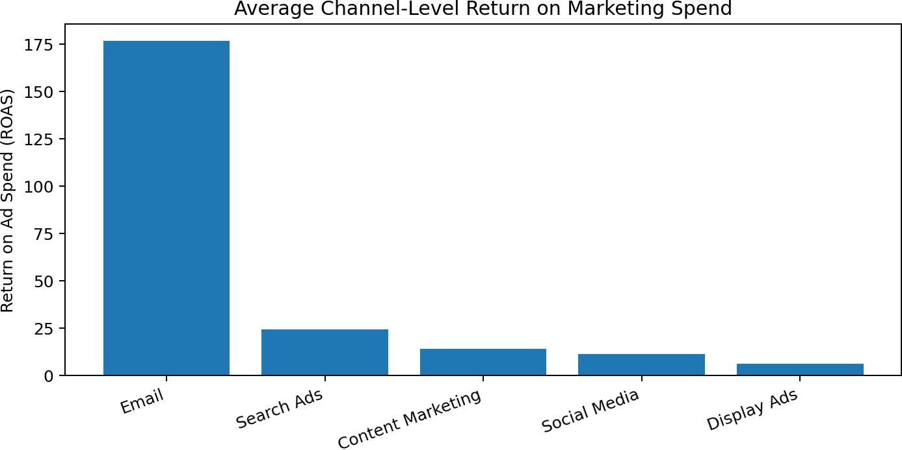

Figure 1. Channel-level ROAS calculated from the illustrative campaign records.
In this generated dataset, Email has the highest channel-level ROAS at 176.79. This result is specific to the assumptions and random values used to create the sample and is not evidence that the channel will perform best in every business context.

Click-Through Rate by Channel
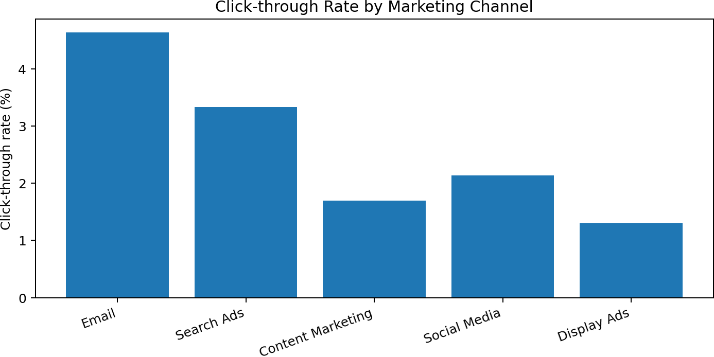

Figure 2. Aggregate click-through rate by channel.
Email records the highest CTR in the synthetic dataset (4.63%). CTR indicates the proportion of impressions that resulted in clicks; it does not by itself establish lead quality or profitability.

Budget and Revenue Relationship
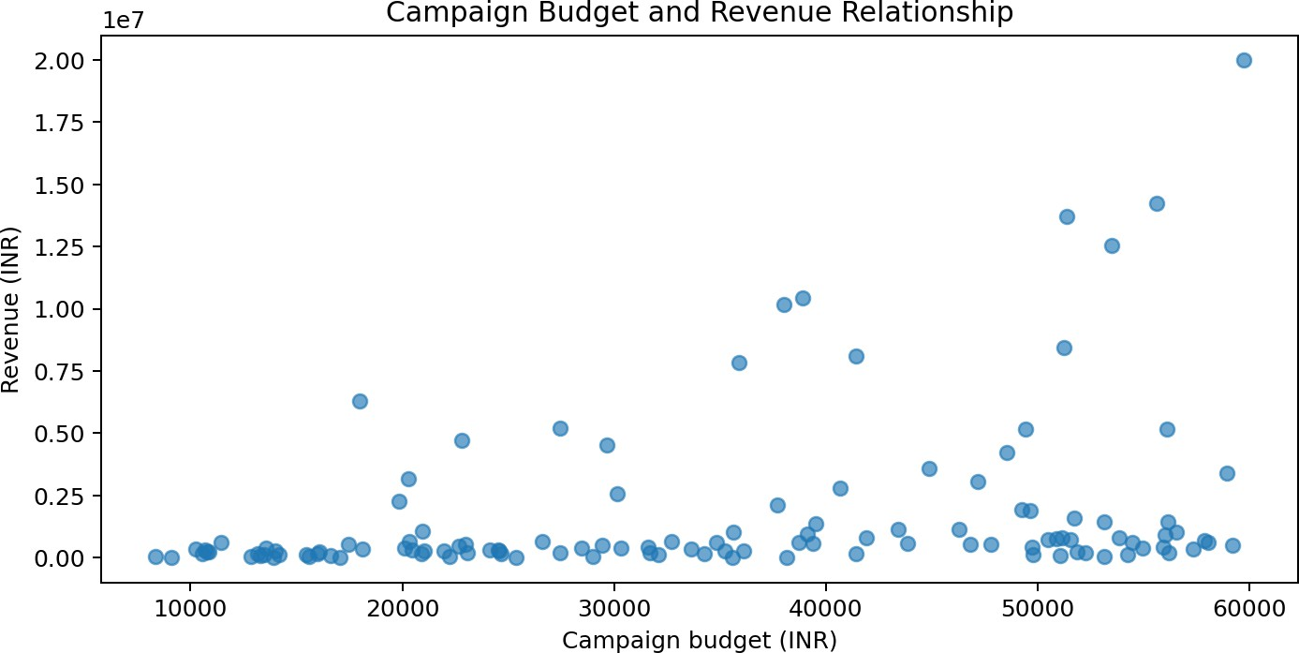

Figure 3. Campaign budget plotted against attributed revenue. The scatter plot shows the spread of campaign outcomes and can help identify records that warrant closer investigation. A visible association should not automatically be interpreted as causation.

Distribution of ROAS
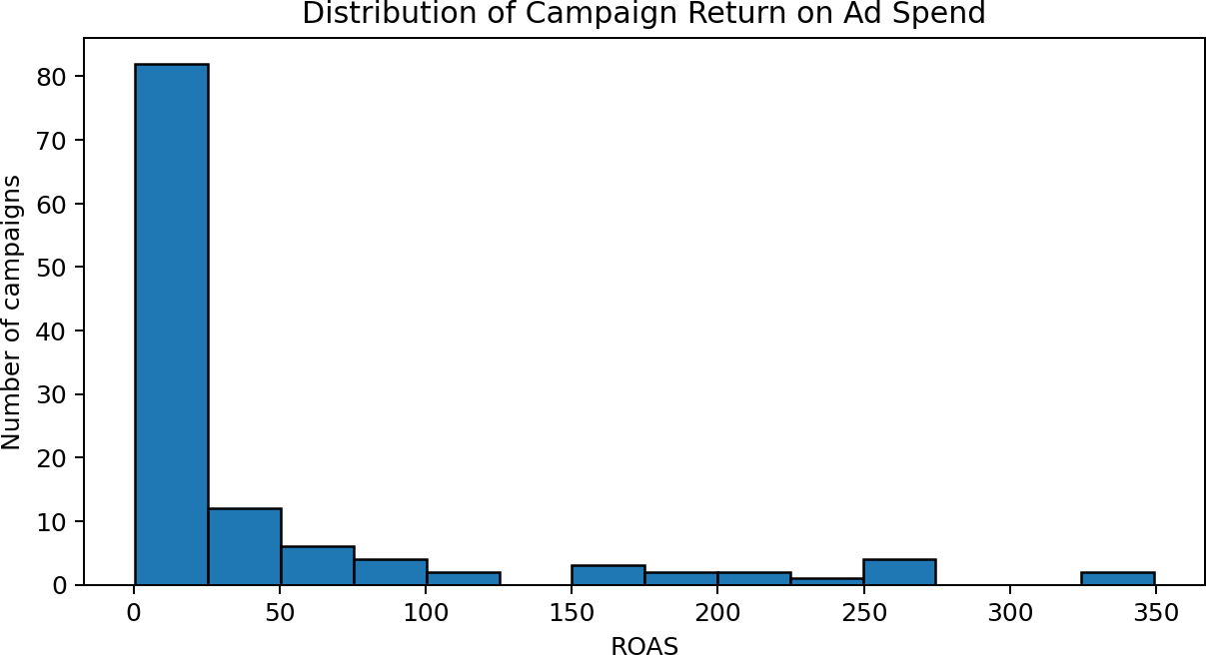

Figure 4. Distribution of campaign-level ROAS. The spread indicates that campaign results vary, making it useful to examine individual campaigns rather than relying only on an overall average.

Key Findings
    - The dataset includes 120 campaign records across five digital channels.

    - Channel-level results vary across CTR, conversion rate and ROAS, demonstrating why multiple indicators are needed.
    - CTR measures response to impressions, while conversion rate measures the proportion of clicks that lead to the defined action.
    - ROAS connects attributed revenue with campaign expenditure but does not account for all business costs or profit margins.
    - The synthetic dataset is useful for demonstrating calculations and reporting, but it cannot establish actual market or company performance.

RECOMMENDATIONS AND SUGGESTIONS

Establish Clear Campaign Objectives
Every campaign should have a clearly defined primary objective, such as awareness, traffic, lead generation or sales. The selected KPIs should match that objective. For example, reach and impressions may be relevant for awareness, while qualified leads and cost per acquisition are more useful for lead generation.

Use a Balanced KPI Dashboard
Marketing teams should monitor a combination of delivery, engagement, conversion and financial indicators. A dashboard should show trends over time and allow users to filter results by channel, campaign, audience and objective.

Improve Tracking and Data Quality
Consistent campaign naming, accurate tracking parameters, conversion-event definitions and regular data checks improve reporting quality. Teams should document attribution windows and ensure that duplicate conversions are not counted more than once.

Optimize Through Controlled Testing
A/B testing can compare creative formats, headlines, landing pages and calls to action. Tests should change a limited number of elements at a time and run long enough to collect sufficient evidence. Decisions should consider statistical uncertainty and business relevance.

Allocate Budgets Carefully
Budget decisions should consider campaign objectives, marginal returns, audience reach, conversion quality and business profitability. The highest observed ROAS should not automatically receive the entire budget, especially when the channel has limited scale or serves an upper-funnel role.

Strengthen Landing-Page Experience
Campaign clicks should lead to relevant, mobile-friendly landing pages with clear information and a simple conversion process. Page speed, form length, trust signals and message consistency can influence the likelihood of conversion.

Protect Customer Privacy
Organizations should collect only necessary information, provide transparent privacy notices, manage consent appropriately and restrict access to customer data. Analytics should be used responsibly and should not create unfair or discriminatory targeting practices.

Review Performance Regularly
A regular review cycle—daily monitoring for delivery issues, weekly optimization and monthly strategic review—can help teams identify problems early while avoiding unnecessary reactions to short-term fluctuations.

LIMITATIONS OF THE STUDY

Synthetic Dataset
The 120 campaign records are generated for learning purposes and do not represent a real organization or platform account.

Limited Sample
The sample size and design are not sufficient to represent all industries, markets, customer groups or campaign types.

Simplified Revenue Attribution
Revenue is assigned directly to campaign records in the simulated dataset. Real customer journeys may involve multiple channels and delayed conversions.

No Profit or Margin Data
ROAS compares revenue with ad spend but does not include product costs, fulfilment, agency fees, salaries or other operating expenses.

Limited Time Dimension
The sample does not provide a detailed time series, so seasonality, campaign fatigue and long-term trends cannot be assessed.

Platform Differences
Advertising platforms may define impressions, clicks and conversions differently. The report assumes consistent definitions for demonstration.

No Causal Inference
Descriptive comparisons do not prove that a channel caused a particular outcome. Other factors may influence performance.
These limitations mean that the results should be treated as illustrative learning outputs rather than operational recommendations for a specific organization.

CONCLUSION
The project demonstrates how digital marketing analytics can be used to organize campaign information, calculate performance indicators and compare results across marketing channels. The study focuses on impressions, clicks, conversions, budget and revenue, supported by derived measures such as CTR, CPC, conversion rate and ROAS.
Using a synthetic dataset of 120 campaign records, the report presents an overall summary, channel-level comparison and visual analysis. The results show that channels can differ across engagement and return indicators, and that no single KPI provides a complete picture of campaign effectiveness.
The study highlights the importance of selecting metrics that align with campaign objectives, maintaining consistent tracking and interpreting revenue-based measures in the context of wider business costs. It also demonstrates that visualizations can make campaign performance easier to communicate to decision-makers.
In conclusion, digital marketing analytics can support more informed planning and optimization when it is based on reliable data and appropriate measurement practices. Further research using authentic platform data, longer observation periods and validated attribution methods would provide stronger insights into actual campaign performance.

LEARNING OUTCOMES
- Developed an understanding of digital marketing channels and their measurement requirements.
- Learned the distinction between impressions, clicks, conversions and revenue outcomes.
- Practised calculating CTR, CPC, conversion rate and ROAS.
- Understood how to organize campaign-level data for analysis.
- Learned to compare channels using tables and charts.
- Recognized the importance of data quality, attribution and privacy.
- Improved the ability to convert numerical findings into practical marketing recommendations.

BIBLIOGRAPHY
- Chaffey, D., & Ellis-Chadwick, F. (2022). Digital Marketing: Strategy, Implementation and Practice. Pearson.
- Kingsnorth, S. (2022). Digital Marketing Strategy: An Integrated Approach to Online Marketing. Kogan Page.
- Farris, P. W., Bendle, N. T., Pfeifer, P. E., & Reibstein, D. J. (2010). Marketing Metrics: The Definitive Guide to Measuring Marketing Performance. Pearson.
- Google Analytics Help. Analytics measurement concepts and reporting documentation. Google.
- Google Ads Help. Campaign performance and measurement documentation. Google.
- Meta Business Help Centre. Advertising performance and measurement resources. Meta.
- IBM Documentation. Data analysis and reporting concepts. IBM.
Note: Consult the latest official platform documentation when applying these concepts to live advertising accounts.

APPENDIX A: SAMPLE DATASET
The following table provides a small extract of the synthetic campaign dataset. The complete dataset contains 120 records; the values below are included to illustrate the structure of the data.

Campaign ID | Channel | Objective | Budget ₹ | Impressions | Clicks | Conversions | Revenue ₹ | CTR % | CPC ₹ | Conv. % | ROAS
DM001 | Display Ads | Website Traffic | 22,972 | 349,020 | 5,279 | 206 | 543,428 | 1.51 | 4.35 | 3.9 | 23.66
DM002 | Search Ads | Website Traffic | 51,131 | 298,486 | 9,672 | 467 | 803,240 | 3.24 | 5.29 | 4.83 | 15.71
DM003 | Display Ads | Brand Awareness | 21,026 | 285,402 | 3,223 | 128 | 260,480 | 1.13 | 6.52 | 3.97 | 12.39
DM004 | Email | Lead Generation | 49,435 | 1,422,472 | 71,091 | 4974 | 5,182,908 | 5.0 | 0.70 | 7.0 | 104.84
DM005 | Social Media | Brand Awareness | 32,076 | 398,007 | 3,598 | 129 | 128,742 | 0.9 | 8.91 | 3.59 | 4.01
DM006 | Content Marketing | Lead Generation | 20,097 | 358,603 | 3,665 | 188 | 401,756 | 1.02 | 5.48 | 5.13 | 19.99
DM007 | Display Ads | Lead Generation | 25,381 | 318,969 | 991 | 12 | 13,992 | 0.31 | 25.61 | 1.21 | 0.55
DM008 | Display Ads | Brand Awareness | 35,600 | 507,789 | 1,523 | 6 | 19,164 | 0.3 | 23.37 | 0.39 | 0.54
DM009 | Social Media | Brand Awareness | 47,788 | 444,293 | 7,522 | 190 | 539,600 | 1.69 | 6.35 | 2.53 | 11.29
DM010 | Search Ads | Website Traffic | 39,513 | 231,400 | 8,908 | 550 | 1,348,600 | 3.85 | 4.44 | 6.17 | 34.13
DM011 | Search Ads | Brand Awareness | 56,528 | 399,305 | 12,893 | 406 | 1,030,022 | 3.23 | 4.38 | 3.15 | 18.22
DM012 | Content Marketing | Sales | 53,123 | 925,735 | 17,761 | 667 | 1,459,396 | 1.92 | 2.99 | 3.76 | 27.47

All appendix values are illustrative and were generated for this report. The complete synthetic dataset can be created or supplied separately if required.

APPENDIX B: SCREENSHOT / VISUAL EVIDENCE NOTE
The four figures embedded in Section 7 are generated analytical charts based on the synthetic dataset. They are not screenshots captured from IBM SPSS Modeler, Google Analytics, Meta Ads Manager or any live advertising platform. If an institution requires authentic software screenshots, the dataset should be imported into the relevant software, the analysis should be run, and genuine screen captures should be inserted with their actual output values.
Suggested authentic evidence to capture during practical work:
- Dataset view showing campaign fields and records.
- Data preparation or variable-properties view.
- Channel-level summary or pivot output.
- Chart or dashboard showing CTR, conversion rate or ROAS.

